# **Last Session**

# **MAIL MERGE**

* EMAIL USING MAIL MERGE
* PRINT USING MAIL MERGE
* EDIT USING MAIL MERGE

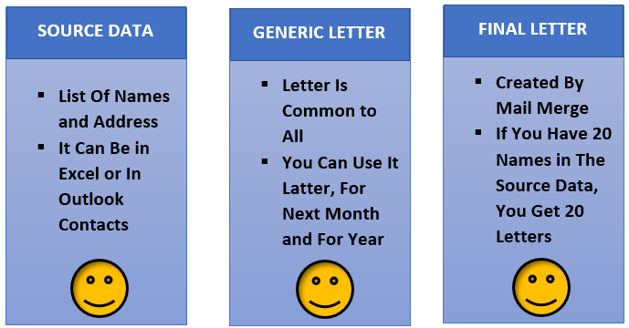

(Date)

Dear ,

You (canceled OR did not show for) your follow-up appointment on (indicate date) without rescheduling. We have tried multiple times to reschedule your missed appointment. To date, you have not responded to our efforts. Since we have not heard from you, we can only conclude that you have terminated your care with our practice.

Continued care is essential to your health, and failure to adhere to the agreed upon plan of care may have significant consequences. (If the patient has a condition that requires specific care, state the care as well as the consequences of not following up in clear layman’s terms. If the patient has a condition that needs periodic follow-up, state the frequency and urgency of the follow-up, and state the consequences of not getting the follow-up at the recommended time interval in clear, patient-friendly language.)

If we do not hear from you by (date at least 30 days from date of letter), we will no longer be able to serve as your provider. We recommend that you promptly find another provider to tend to your healthcare needs (state needs if continual medical attention is necessary, e.g., treatment to clear active infection). Delays could jeopardize your health.

We will remain available to provide services to you on an emergency basis only, until (same date as specified above) when you have the opportunity to arrange for another provider to assume your care. A medical records release authorization form is needed, so if you are not returning for care with us, please notify our office with the name and address of your new provider. Upon receipt of your signed authorization, we will forward a copy of your medical record. We will also be happy to discuss your medical condition(s) with the provider who assumes your care.

Very truly yours,

cc: File Reducing Risk